RAG Chatbot using SQuAD Dataset
Project Overview:
This project is a Retrieval-Augmented Generation (RAG) based Question Answering System built using the SQuAD 2.0 Dataset.
The system allows users to ask natural language questions and retrieves accurate answers from a large knowledge base (Wikipedia-style passages) using semantic search and a transformer-based language model.
Unlike traditional chatbots, this system does not rely only on pre-trained knowledge. Instead, it retrieves relevant context from a dataset and then generates answers based on that context.

Features;
- Uses real-world QA dataset (SQuAD 2.0)
- Text preprocessing (cleaning & normalization)
- Chunking of large documents for efficient processing
- Embedding generation using Sentence Transformers
- Fast similarity search using FAISS vector database
- Transformer-based answer generation (Flan-T5)
- No Answer Found” logic to prevent hallucinations
- Interactive chatbot UI using Streamlit

Tech Stack:
- Python
- LangChain
- FAISS (Vector Database)
- HuggingFace Transformers
- Sentence Transformers
- Streamlit
- Google Colab (Development)

How It Works (RAG Pipeline):
- Load Dataset (SQuAD JSON files)
- Preprocess Text (cleaning & normalization)
- Split into Chunks (for better retrieval)
- Convert to Embeddings
- Store in FAISS Vector DB
- User asks a question
- Retrieve relevant chunks
- Generate answer using LLM
- Return response OR “No answer found” if irrelevant
Project Structure:
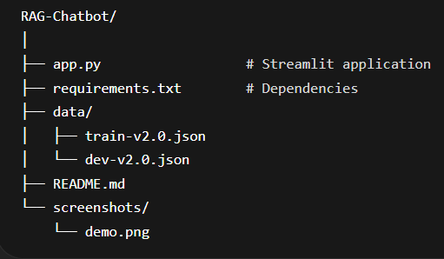

Hallucination Control:
The system includes a similarity-based threshold:
- If no relevant context is found
System returns:
“No relevant answer found in dataset.”
This ensures safe and reliable responses.

Future Improvements:
- Chat history memory (like ChatGPT)
- Better ranking strategy (reranking model)
- Multi-document reasoning (HotpotQA support)
- Faster vector search optimization

Learning Outcome:
This project demonstrates:
- Real-world NLP pipeline design
- Retrieval-Augmented Generation (RAG)
- Vector databases (FAISS)
- Transformer-based NLP models
- End-to-end AI application deployment

